**ASE HACKATHON**

**Class Diagram:**



**Architecture Diagram:**



**Features Implemented:**

Implemented basic features login, signup. Then implemented creating events, sending email invitations to the guests and adding items to the wish list.

**a) Web Services:**

Used SOAP web services for login and signup.

**b) Database:**

Used SQL server 2012 database in local and cloud.

**c) Mobile Interface Design:**

Used JQuery mobile for designing the mobile interface.

ii) **Existing Design:**

Used J Query libraries in Microsoft visual studio.

**Screen Shots of the design:**

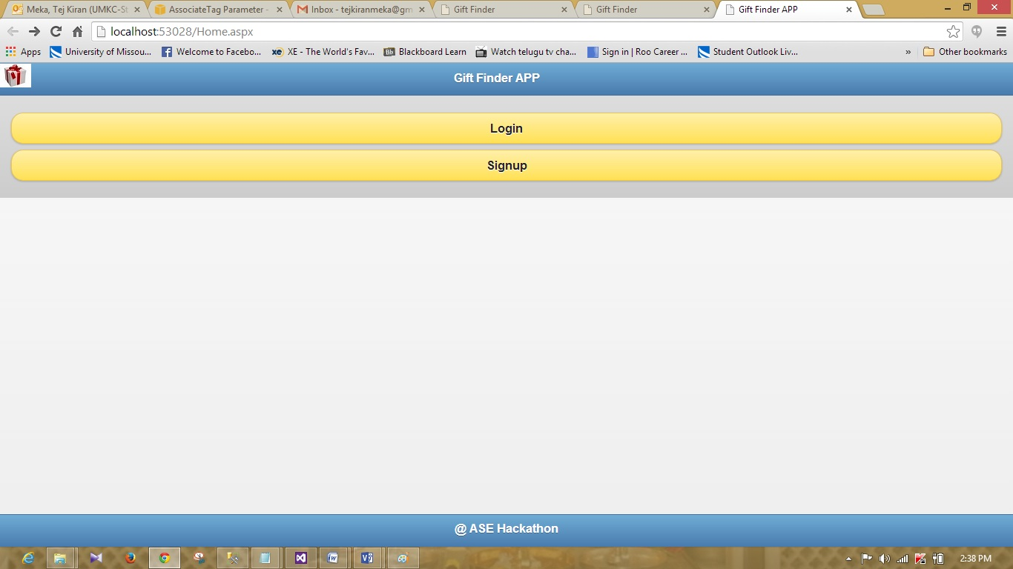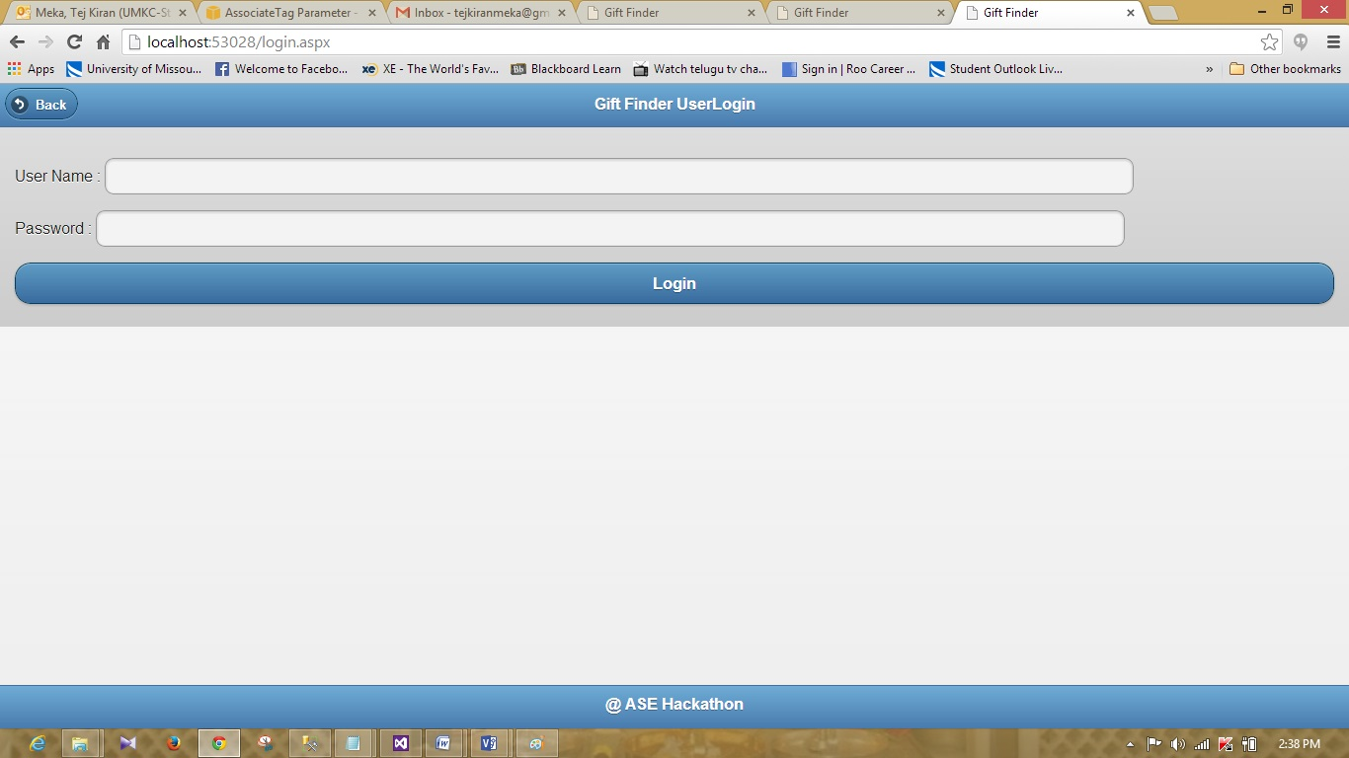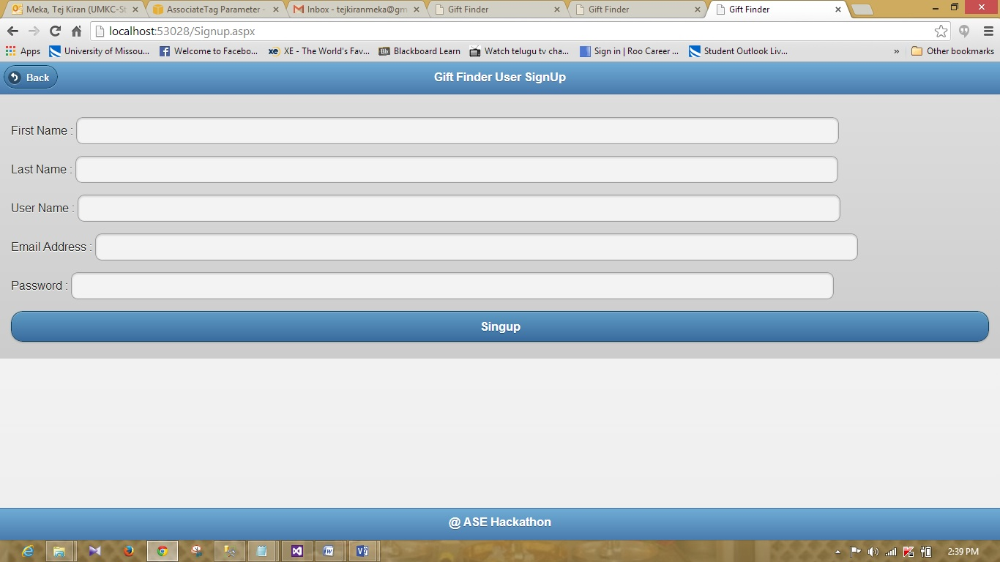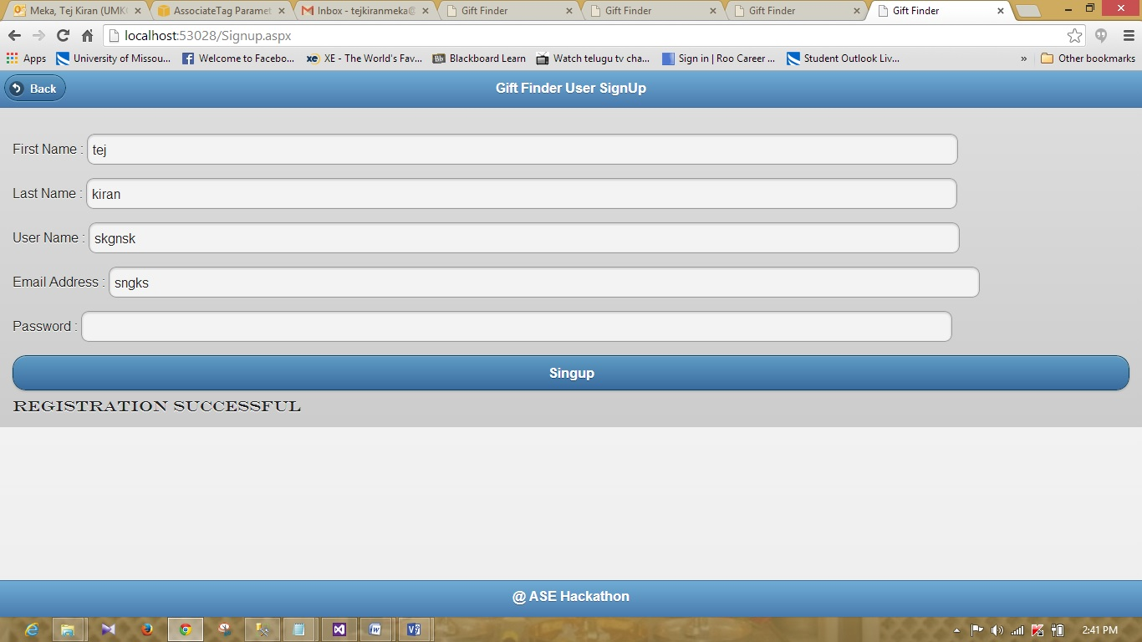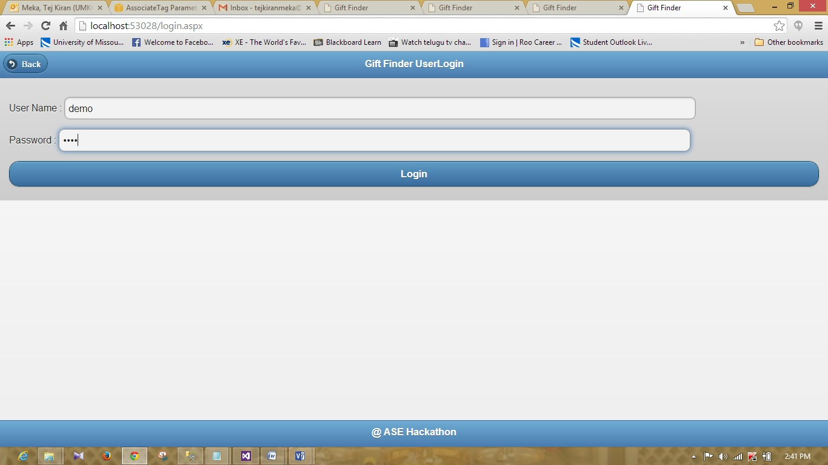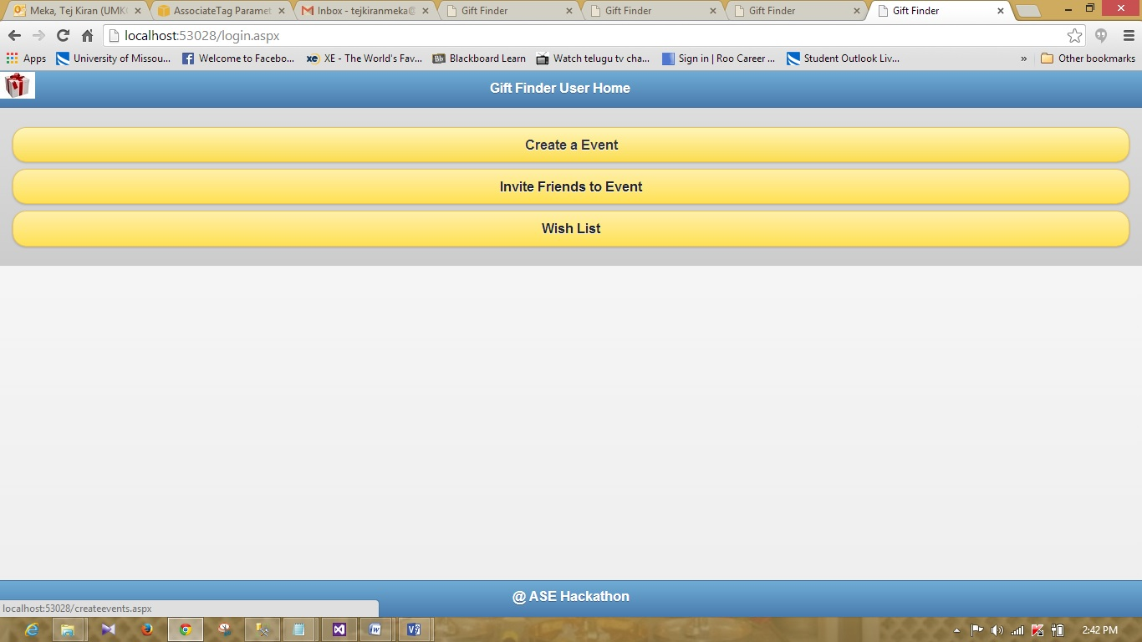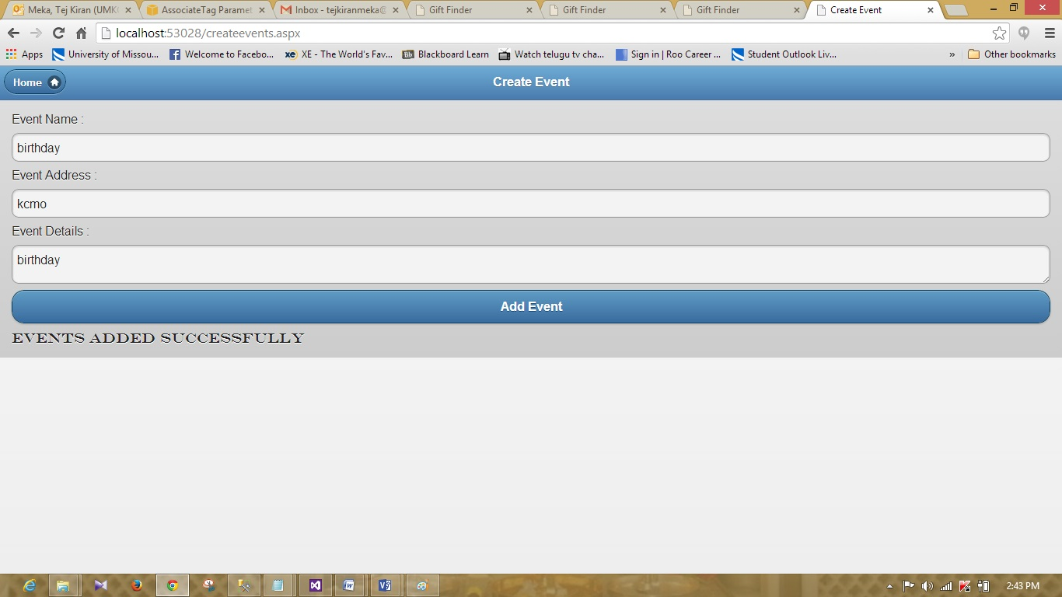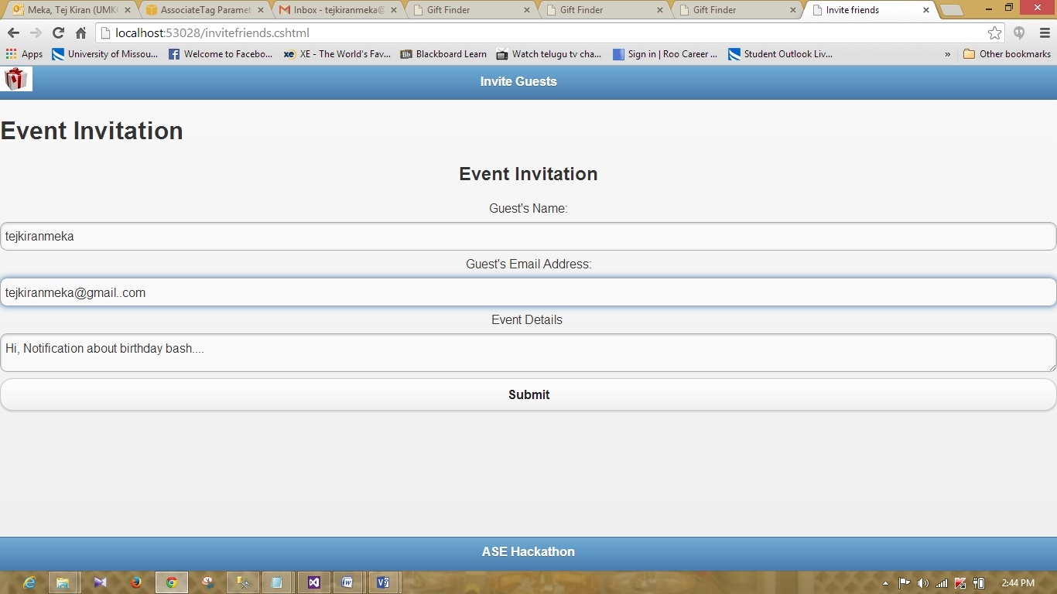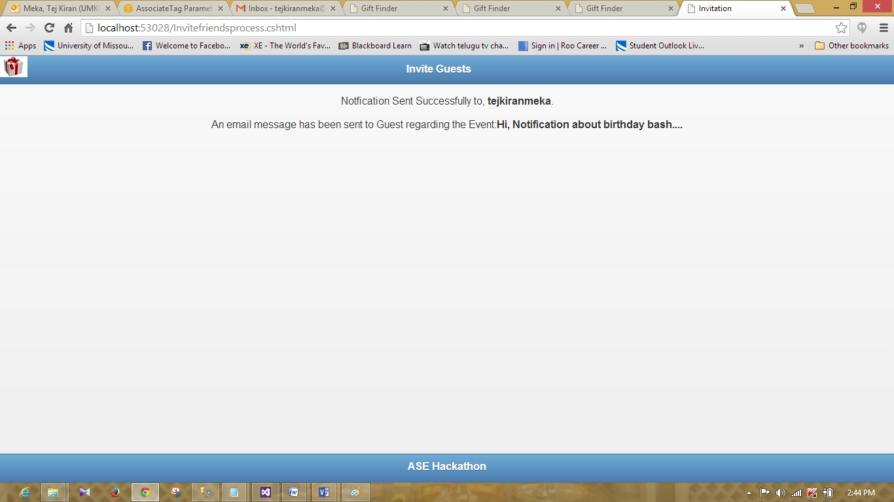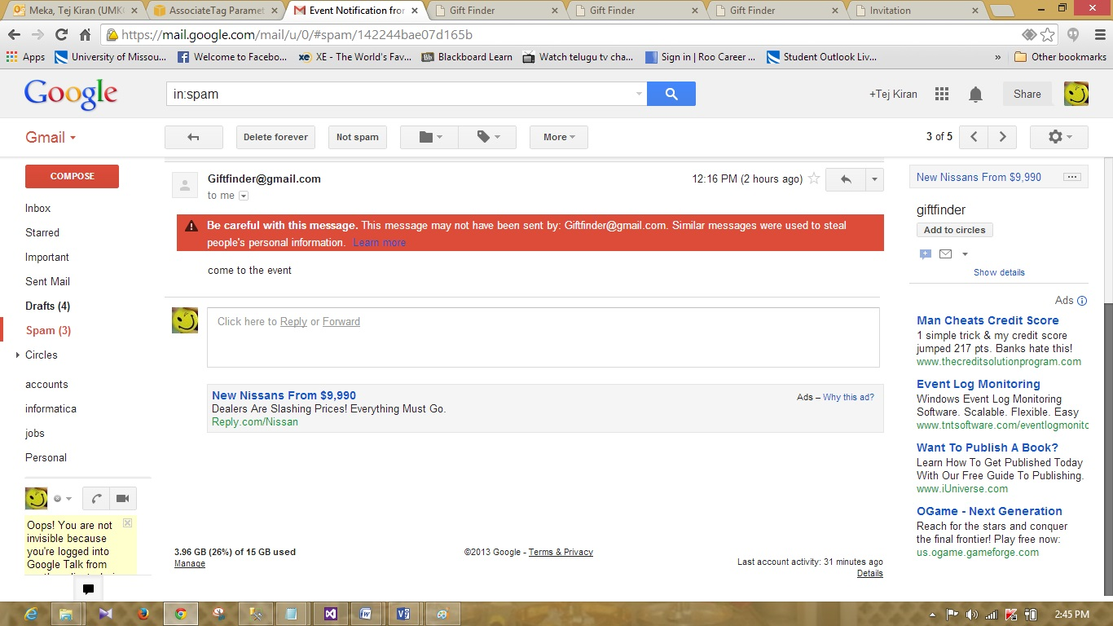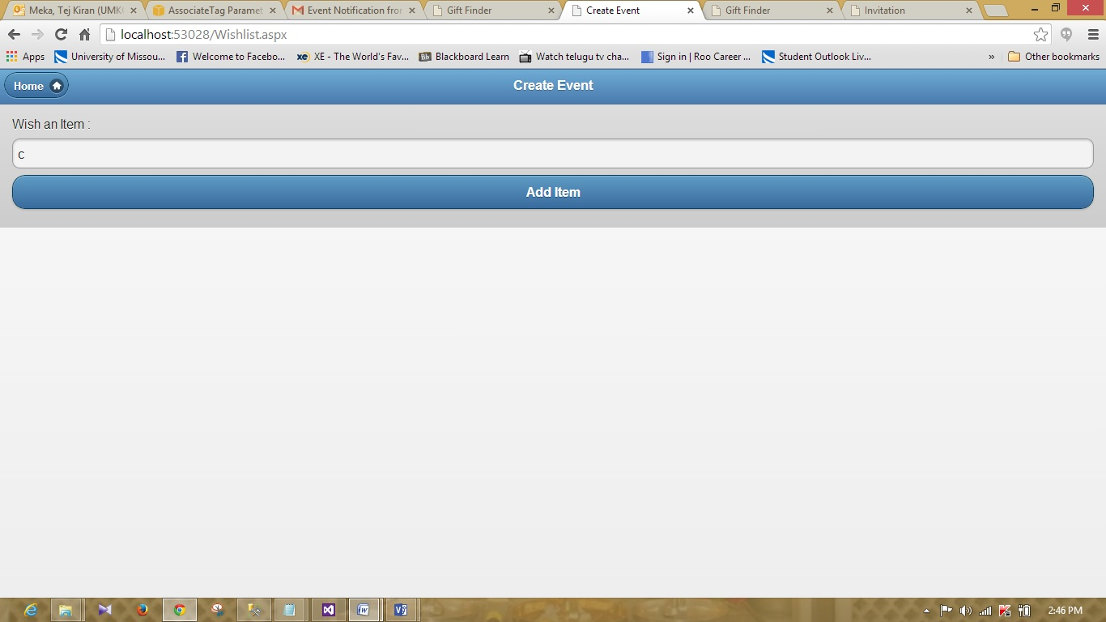

**Web Services:**

Implemented Login and Signup services.

**Limitations:**

Have issues with data base connectivity. When the data is entered into Signup and wish List forms the data is note entered into the database.

So implemented the login service with pre assigned username = demo and password = demo